Old Mutual

Group Balance Sheet Management

Developer Screening Test

Calculating the profit of an organisation

General Notes

* **Read the question carefully!**
* Then read the question carefully again.
* You can write the solutions to these questions in whatever language you feel most comfortable.
* Your solution must be runnable by us, so that we can test it. If you use something exotic, please provide instructions as to how to run it.
* Your solutions should be general enough to work for any input that conforms to the same format.
* We suggest that you put the example inputs given into files (whatever format is convenient for you) and read them in at the start of your solution.
* We will test your solution with some other datasets, be aware of this.
* Think about edge-cases and handle them appropriately.
* We are far more concerned with the structure of your code, and the algorithms you write, than the fancy interface you build. Don’t build a giant web-app or GUI, it’s not necessary. Write enough code to solve the problems elegantly.
* Comment your code!

Introduction

We have an organisation which has a head-office, and several country offices which report to it. Each country office has provincial offices which report to it. This breakdown continues arbitrarily (regions, cities, suburbs, etc. There is no limit as to how far down the breakdown can go).

Each office makes money. At the end of the year, we want to know how much nett profit each office has made.

**Definitions:**

|  |  |
| --- | --- |
| Term | Definition |
| Descendant | Any office reporting directly to the office in question.  In the diagram below, the descendants of the US would be California and New York. |
| Nett profit | The amount of the money an office has made, plus the sum of the nett profits of its descendants. |

Question 1

Write a solution to calculate the nett profit any office has made.

**Important:** Although we have given you an example organisational diagram and examples of how much money each office made, your solution MUST be able to work with any valid organisational diagram and for any values of money made. Do not just hard code a solution for this input.

Example DataSet

You are given a csv file containing the hierarchy and the money made by each office.

Each line in the csv file contains:

* The name of the office
* The name of the office this office reports to (its parent office)
* The amount the office made (not including its descendants)

Example file:

Office,Parent,Amount

HeadOffice,,10

South Africa,HeadOffice,30

KZN,South Africa,30

eThekwini,KZN,10

Durban,eThekwini,15

Pinetown,eThekwini,20

Western Cape,South Africa,20

Cape Town,Western Cape,22

Northern Suburbs,Cape Town,5

Southern Suburbs,Cape Town,10

Bellville,Northern Suburbs,10

Claremont,Southern Suburbs,15

Newlands,Southern Suburbs,100

US,HeadOffice,30

New York,US,50

California,US,40

Los Angeles,California,25

San Francisco,California,35

UK,HeadOffice,70

London,UK,80

This file should create a hierarchy like this:

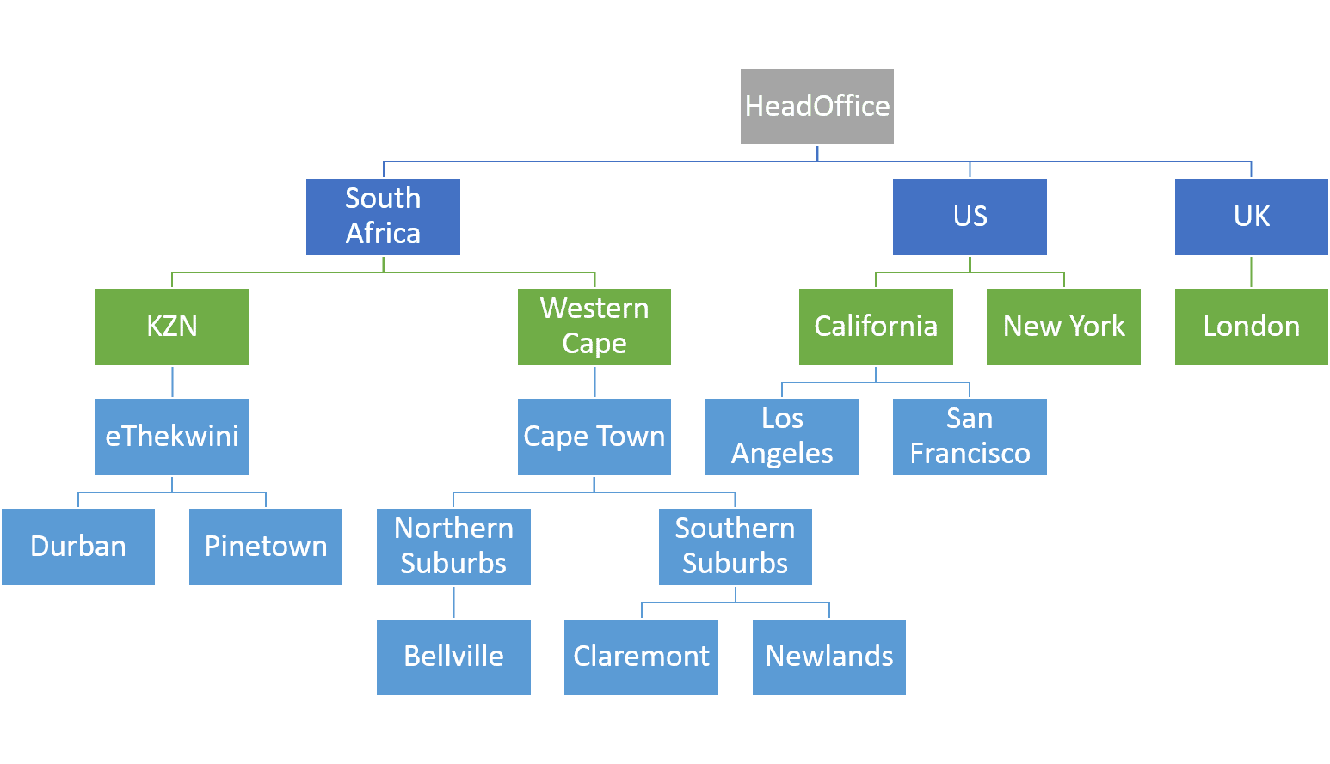

Your solution should read in the file, then request an office to calculate the nett profit for.

It should then display the nett profit.

**Example Answers to Question 1:**

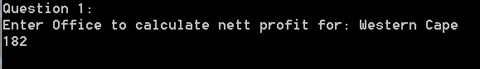



Question 2

Write a solution to find the office that has made the largest nett profit (as always, including descendants).

**Important:** Assume that offices can make a loss (i.e. that the amount of money an individual office makes can be either positive or negative).

Example Input

Office,Parent,Amount

HeadOffice,,10

South Africa,HeadOffice,-30

KZN,South Africa,30

eThekwini,KZN,-10

Durban,eThekwini,15

Pinetown,eThekwini,-20

Western Cape,South Africa,20

Cape Town,Western Cape,22

Northern Suburbs,Cape Town,-5

Southern Suburbs,Cape Town,10

Bellville,Northern Suburbs,10

Claremont,Southern Suburbs,15

Newlands,Southern Suburbs,100

US,HeadOffice,30

New York,US,-50

California,US,-40

Los Angeles,California,25

San Francisco,California,35

UK,HeadOffice,-70

London,UK,80

Your solution should read in the input, then immediately display the office with the largest nett profit, as well as the value of that nett profit.

Write a short paragraph detailing how you approached this question, and why you chose the algorithms/data structures you did.